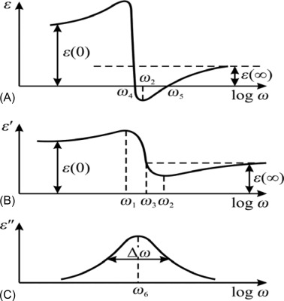
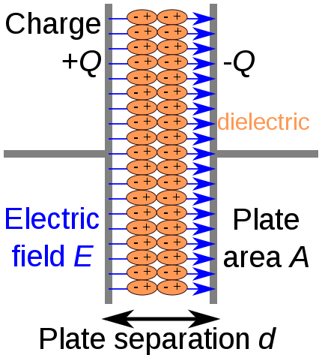
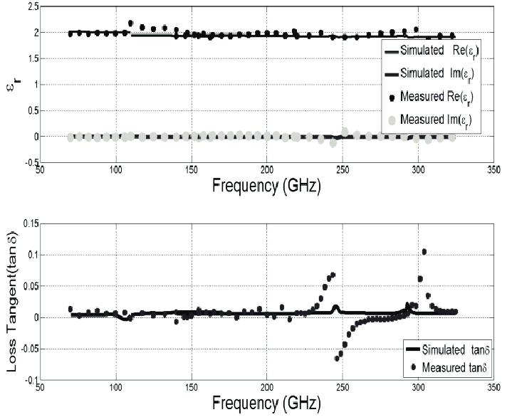
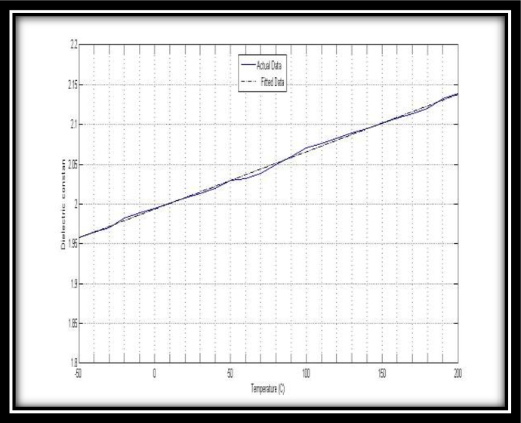
From an engineering and physical perspective, what you are observing is dielectric polarization and relaxation in the insulation material surrounding the conductor. With high voltage applied and then removed, the dielectric does not discharge instantaneously; instead, part of the stored energy reappears as a residual voltage. This is a well-known phenomenon and is especially relevant in precision, high-voltage, or low-noise systems.

1. What is happening in the dielectric?
When a voltage is applied to a wire, the insulation (dielectric) is exposed to an electric field. Several polarization mechanisms occur:
- Electronic polarization
– Very fast (sub-nanosecond) displacement of electron clouds.
- Atomic (ionic) polarization
– Slight displacement of atoms in the molecular lattice.
- Dipolar (orientational) polarization
– Alignment of permanent molecular dipoles with the field.
- Interfacial / space-charge polarization
– Charge accumulation at material boundaries or defects.
When the voltage is removed:
- The electric field collapses immediately.
- Polarization relaxes with different time constants.
- Some polarization mechanisms release energy slowly → residual charge / voltage re-emergence.
This is typically referred to as dielectric absorption (DA) or soakage.

2. Why this matters in a wire
A wire with insulation behaves as:
- A distributed capacitor
- With lossy dielectric behavior
After discharging the conductor:
- The conductor voltage may “creep back”
- Caused by charge redistribution within the dielectric bulk
This effect becomes noticeable when:
- Voltage is high
- Impedance is high
- Timing is critical (e.g., sampling, precision switching, HV pulse systems)

3. Teflon (PTFE) as a dielectric
PTFE (commonly called Teflon) is generally an excellent dielectric, which is why you are using it.
Key dielectric properties of PTFE
Property | Typical Value | Engineering Implication
Relative permittivity (εr) | ~2.0–2.1 | Low capacitance
Dielectric absorption | ~0.01–0.02% | Extremely low soakage
Dielectric strength | ~60–120 kV/mm | Excellent HV insulation
Volume resistivity | >10¹⁸ Ω·cm | Very low leakage
Loss tangent (tan δ) | ~2×10⁻⁴ | Minimal dissipation
Temperature stability | Excellent | Predictable behavior
Why PTFE behaves well:
- Very low molecular polarity
- Symmetric, non-polar C–F bonds
- Minimal dipolar polarization
- Few charge-trapping sites
As a result:
- Fast relaxation
- Very little residual voltage
- Low memory effect

4. Why you still see stored charge with PTFE
Even with PTFE, you may observe residual effects due to:
- Geometric capacitance
  - Long wire length
  - Close conductor spacing
  - High voltage
- Surface charge
  - Charges trapped at conductor–dielectric or dielectric–air interfaces
- Space charge injection
  - At high electric fields, charge can be injected into the dielectric bulk
- Mechanical stress / defects
  - Micro-voids or impurities increase slow polarization components
- Time-scale mismatch
  - Measurement occurs faster than full dielectric relaxation

5. Engineering model (practical view)
Dielectric absorption is often modeled as:
- An ideal capacitor C
- In parallel with several RC branches, each representing a polarization mechanism
This explains:
- Fast discharge initially
- Followed by slow voltage recovery
In time domain:
- ( V(t) = \sum_i V_i \cdot e^{-t/\tau_i} )
Where:
- ( \tau_i ) are relaxation time constants (microseconds → minutes)

6. Comparison with other dielectrics (context)
Material | Dielectric Absorption | Suitability
PTFE (Teflon) | Very low | Excellent
Polyethylene (PE) | Low | Very good
Polypropylene (PP) | Very low | Excellent
PVC | Moderate | Poor for precision
Polyimide (Kapton) | Moderate | Depends on application
Epoxy | High | Avoid for HV precision
PTFE is among the best available practical dielectrics for minimizing stored charge effects.

7. Mitigation strategies (if it still matters)
If the residual charge is problematic:
- Use bleeder resistors to define discharge paths
- Minimize insulation thickness consistent with HV rating
- Avoid sharp field gradients
- Shield or guard high-impedance nodes
- Allow settling time after HV removal
- Consider PP or expanded PTFE if mechanically feasible

8. Bottom line
From an engineering standpoint:
- What you see is normal dielectric relaxation, not a flaw
- PTFE already minimizes the effect
- Any remaining charge is dominated by geometry, interfaces, and field strength rather than material choice
- If PTFE is insufficient, the issue is usually system-level, not dielectric-level
If you want, we can:
- Quantify expected residual voltage vs. time
- Model your wire geometry as a distributed RC network
- Compare PTFE vs. PP numerically for your voltage and timing regime

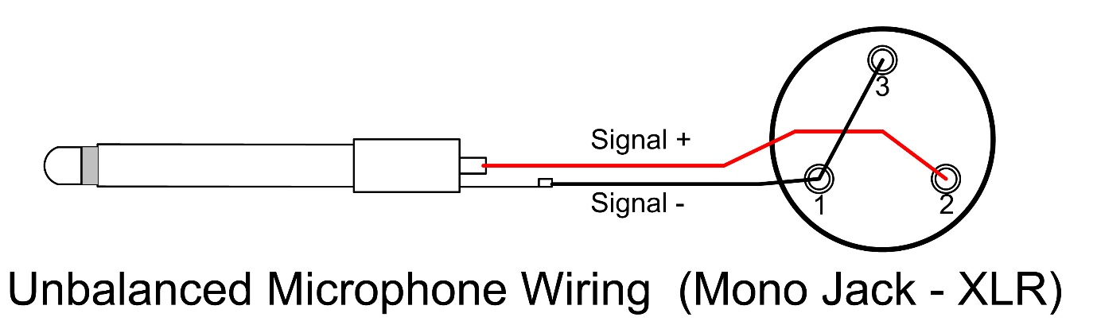
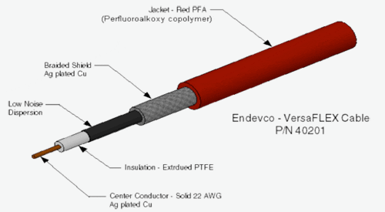

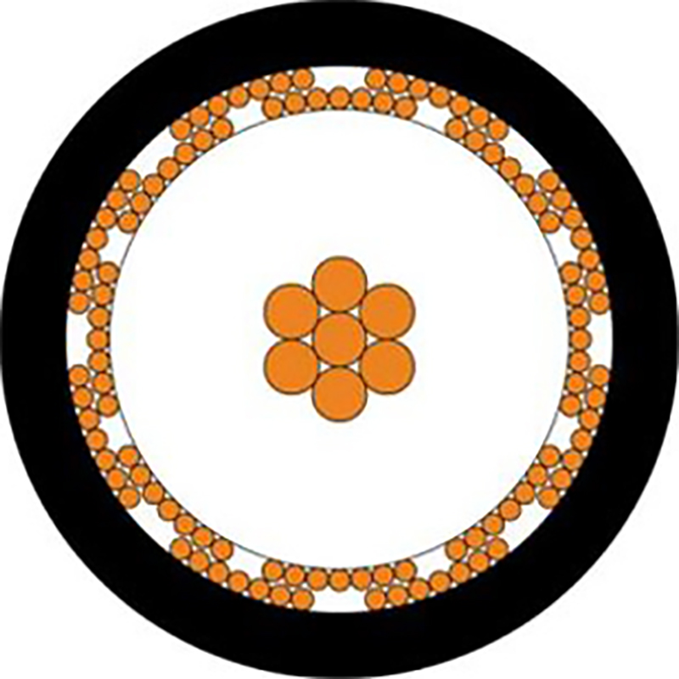
A microphonic cable is a cable in which mechanical motion is converted into an electrical signal. From an engineering standpoint, the cable behaves like an unintended sensor: vibration, bending, or rubbing modulates charge distribution inside the insulation and appears as noise at the conductor.
This effect is critical in high-impedance, low-level signal paths (audio, microphones, sensors, electrometers, HV sense lines).

1. Physical mechanisms (what actually causes it)
Several mechanisms may contribute simultaneously:
1. Triboelectric effect (dominant in most cables)
- Mechanical motion causes friction between conductor and dielectric
- Electrons are exchanged → charge redistribution
- Appears as a voltage source in series with the signal
- Strongly dependent on dielectric material
This is the primary cause in most audio and sensor cables.

2. Dielectric polarization modulation
- Bending or compression changes the electric field distribution
- Stored polarization charge is redistributed
- Equivalent to modulating the cable’s capacitance and DA behavior
This links directly to your earlier question about stored charge in dielectrics.

3. Piezoelectric effects (material-specific)
- Some materials generate charge when stressed
- Common in certain polymers and crystalline fillers
- PTFE itself is not piezoelectric, but additives or layered constructions can be

4. Geometry-induced capacitance modulation
- Movement changes conductor spacing
- In high-impedance circuits, even femtofarad changes create measurable voltage

2. Why PTFE (Teflon) matters here
PTFE has very low dielectric absorption, which is good, but:
PTFE is mechanically stiff and low-loss, which means:
- Mechanical energy is not well damped
- Charge movement is not dissipated quickly
- Result: sharp, high-frequency microphonic spikes
So paradoxically:
- PTFE is excellent electrically
- But can be microphonic if not mechanically controlled
This is why raw PTFE-insulated wire can be microphonic in sensitive applications.

3. Electrical model (engineering abstraction)
A microphonic cable can be modeled as:
- Signal conductor
- In parallel with:
  - Capacitance C(x)
  - A motion-dependent charge source q(x, t)
Where:
- Mechanical displacement → ΔC and Δq
- High input impedance converts this directly into voltage:
$$V_{\text{noise}}=\frac{Δq}{C}$$
This explains why:
- The same cable is quiet into 50 Ω
- But noisy into a FET gate or op-amp input

4. Where it becomes a problem
Microphonic effects dominate when:
- Source impedance > ~100 kΩ (often much higher)
- Signal levels are low (µV–mV)
- Cable is long or mechanically unconstrained
- Cable is subject to vibration or airflow
Common problem cases:
- Microphone cables
- Piezo sensors
- HV measurement leads
- Capacitive sensors
- Chopper / sample-and-hold inputs

5. How “low-noise” cables fix this
Purpose-built low-microphonic cables typically use:
- Conductive inner layer (carbon-loaded polymer)
  - Bleeds triboelectric charge
  - Provides controlled leakage path
- Soft dielectric (PE, foamed PE, PP)
  - Lower friction
  - Mechanical damping
- Tight mechanical bonding
  - Prevents relative motion between layers
- Graphite-coated PTFE (in premium designs)
  - Keeps PTFE’s electrical benefits
  - Suppresses charge buildup

6. Comparison of dielectrics for microphonics
Dielectric | Dielectric Absorption | Microphonic Risk
PTFE (solid) | Very low | Medium–High
PTFE + conductive layer | Very low | Low
Polyethylene (PE) | Low | Low
Foamed PE | Low | Very low
Polypropylene (PP) | Very low | Low
PVC | Moderate | Low (but noisy electrically)

7. Practical mitigation strategies
From a system-engineering perspective:
- Lower the input impedance where possible
- Add a bias / bleed resistor (10 MΩ–1 GΩ depending on noise budget)
- Use graphite-coated or “low-noise” cable
- Mechanically clamp the cable near sensitive nodes
- Avoid free-hanging cable sections
- Route away from vibration sources
- Prefer twisted pair with shield over single-ended HV lines

8. Bottom line
- A microphonic cable is not “bad insulation” — it is electromechanical coupling
- PTFE minimizes dielectric memory but does not automatically minimize microphonics
- Microphonics are dominated by triboelectric charging and mechanical motion
- The solution is usually construction and termination, not just material choice
If you want, you can provide:
- Signal impedance
- Voltage level
- Cable length
- Mechanical environment
and I can recommend a specific cable construction or quantify expected noise levels.

A twisted cable (twisted pair) is often used specifically to reduce noise and microphonic sensitivity, but it is important to understand why it helps—and what it does not eliminate.

1. Why twisting helps (physical explanation)
1. Field symmetry and charge cancellation
In a twisted pair, the two conductors:
- Experience nearly identical mechanical stress
- Experience nearly identical dielectric deformation
- See opposite polarity electric fields (for differential signals)
Any mechanically induced charge or capacitance change tends to be common-mode.
If the receiver measures differentially, the induced noise cancels:
$$V_{\text{diff}}=V_{1}-V_{2}≈0$$
This is the primary reason twisted pairs are effective against:
- Microphonics
- EMI pickup
- Capacitance modulation

2. Microphonics in twisted cables
What twisting reduces
- Triboelectric noise: motion-induced charge is similar in both conductors
- Capacitance modulation: geometry changes affect both lines equally
- External vibration coupling
What twisting does NOT eliminate
- Absolute charge generation still exists
- Common-mode noise remains
- Single-ended measurements still see noise
So:
- Twisted pair + high-impedance single-ended input → still microphonic
- Twisted pair + differential input → very low microphonic sensitivity

3. Dielectric role inside twisted pair
Even with twisting, the dielectric matters:
Dielectric | Triboelectric Tendency | Mechanical Damping
Solid PTFE | High | Low
Foamed PE | Low | High
PP | Low | Medium
PVC | Low | High (but electrically lossy)
PTFE twisted pair:
- Electrically excellent
- Mechanically “springy”
- Can generate sharp noise impulses if unconstrained
This is why instrumentation twisted pairs often use:
- PE or foamed PE
- Or PTFE with a conductive inner layer

4. Shielded twisted pair (STP)
Adding a shield improves behavior further:
- Shield acts as a charge sink
- Reduces surface charge accumulation
- Reduces electric field modulation in the dielectric
Best practice:
- Shield bonded to low-impedance ground
- Twisted pair inside remains floating or biased
However:
- Poor shield termination can increase microphonics due to shield motion

5. Equivalent engineering model
A twisted pair under vibration can be modeled as:
- Two matched capacitors $C_{1}(t),C_{2}(t)$
- Two charge sources $q_{1}(t),q_{2}(t)$
With good symmetry:
$$q_{1}(t)≈q_{2}(t),C_{1}(t)≈C_{2}(t)$$
Differential noise:
$$V_{n}∝\frac{q_{1}-q_{2}}{C}$$
Twisting minimizes $q_{1}-q_{2}$, not $q$itself.

6. Practical guidance (engineering rules)
Use twisted cable when:
- Source impedance is high
- Signal is differential
- Cable is exposed to vibration
- Cable length is significant
To further reduce microphonics:
- Mechanically clamp cable near connectors
- Avoid free-hanging loops
- Add a high-value common-mode bleed resistor
- Prefer shielded twisted pair with dissipative dielectric

7. Bottom line
- Twisting does not remove dielectric charge generation
- It converts it into common-mode noise
- Differential receivers reject it effectively
- With PTFE insulation, mechanical control is still essential
If you want, describe:
- Differential or single-ended?
- Source impedance level?
- Voltage swing?
- Cable length and vibration environment?
I can then recommend a specific twisted-pair construction and termination strategy.

